**Exploring Sanya's Coastal Wonders: Different Bays Offering Unique Travel Experiences**

With a coastline stretching 264.42 kilometers, Sanya has become a dream destination for both domestic and international visitors, thanks to its continuous coastline and diverse natural and cultural landscapes. The city features several distinct bays—Haitang Bay, Yalong Bay, Dadonghai, Sanya Bay, and Yazhou Bay—each offering unique charm and catering to various travel imaginations.

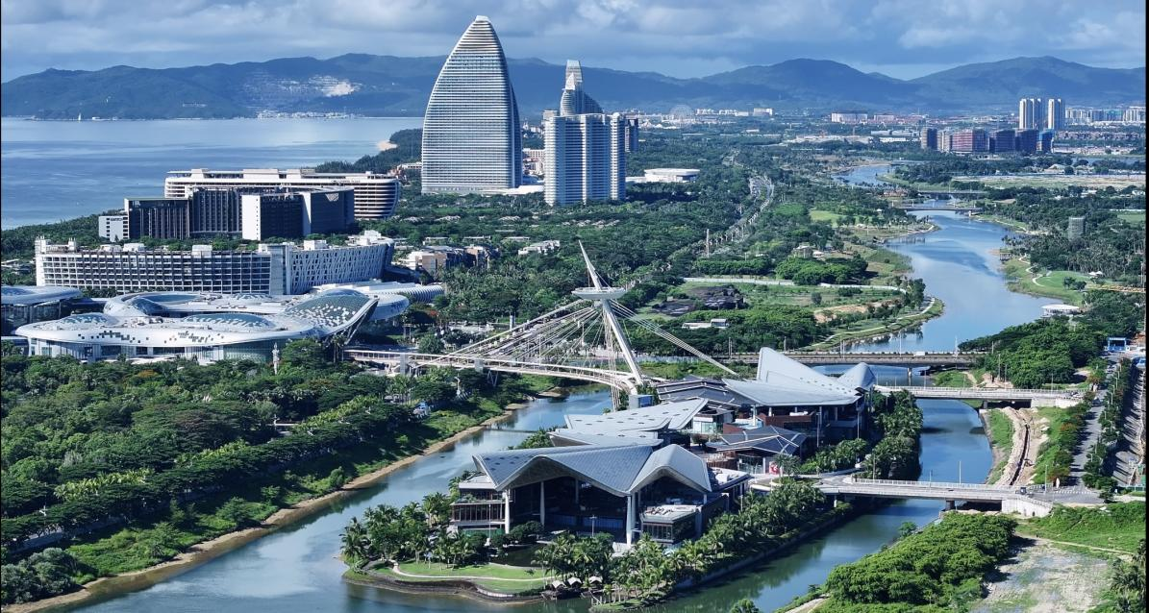**【Haitang Bay: A New Choice for High-End Coastal Retreats】**

Haitang Bay stands out with its upscale beachfront resort offerings, drawing attention from global leisure travelers. The area is renowned for its picturesque scenery and tranquil ambiance, with numerous luxury villas providing high privacy. The Sanya Pearl River NanTian Hot Spring Resort, for example, incorporates hot springs into its residences, offering guests the ultimate relaxation amid natural beauty. As high-end amenities like international brand hotels and duty-free shopping malls continue to develop, Haitang Bay is rapidly becoming a new favorite in the global luxury tourism market.

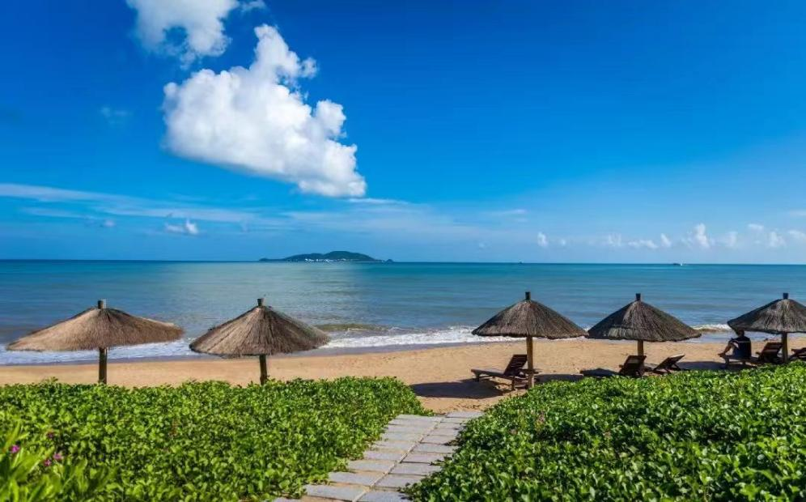**【Yalong Bay: The Perfect Blend of Nature and Leisure】**

Known as "The World's No.1 Bay," Yalong Bay is a crescent-shaped bay approximately 7.5 kilometers long, with shallow waters extending 50-60 meters wide, accommodating nearly 100,000 visitors for water activities. Surrounded by lush mountains and facing the South China Sea, the bay offers stunning views at sunrise and sunset. Its fine sandy beaches and 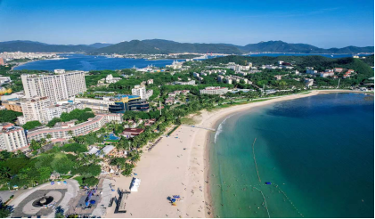clear waters make it ideal for various water sports and diving. The surrounding area boasts several international brand hotels, providing extensive leisure and entertainment facilities, as well as diverse dining options. Nearby commercial complexes like the Hundred Flower Valley and Outlet Town add to the convenience, making Yalong Bay a perfect spot for relaxation and vacation.

**【Dadonghai: A Blend of Bustling Energy and Tranquility】**

Located between Yulin Port and Lu Hui Tou, Dadonghai is the most densely populated bay area in Sanya, offering a vibrant urban atmosphere with a wide range of water activities. It’s an ideal destination for those seeking excitement and fresh experiences, whether enjoying sunbathing during the day or lively nightlife in the evening.

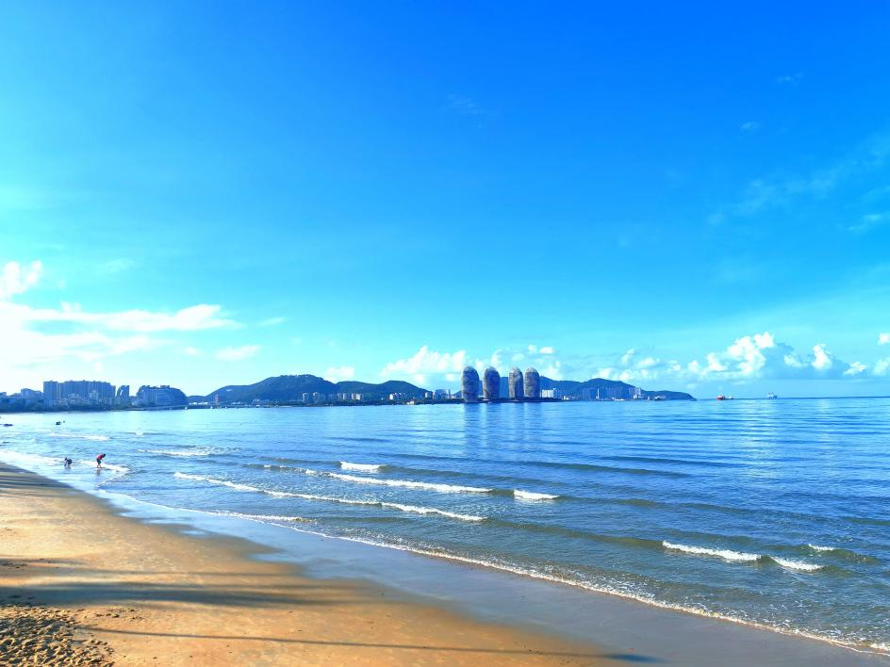**【Sanya Bay: A Family-Friendly Choice with a Rich Local Atmosphere】**

Stretching 22 kilometers, Sanya Bay is the longest bay in Sanya. Its wide sandy beaches and picturesque Coconut Dream Corridor offer a beautiful setting. Proximate to Sanya’s city center and Phoenix International Airport, it features complete living amenities. Whether for family outings, leisurely beach walks, or sunset views, Sanya Bay is an excellent choice. The bay's appeal is further enhanced by the completion of its marine ecological restoration project, which has increased its charm as an "ocean living room."

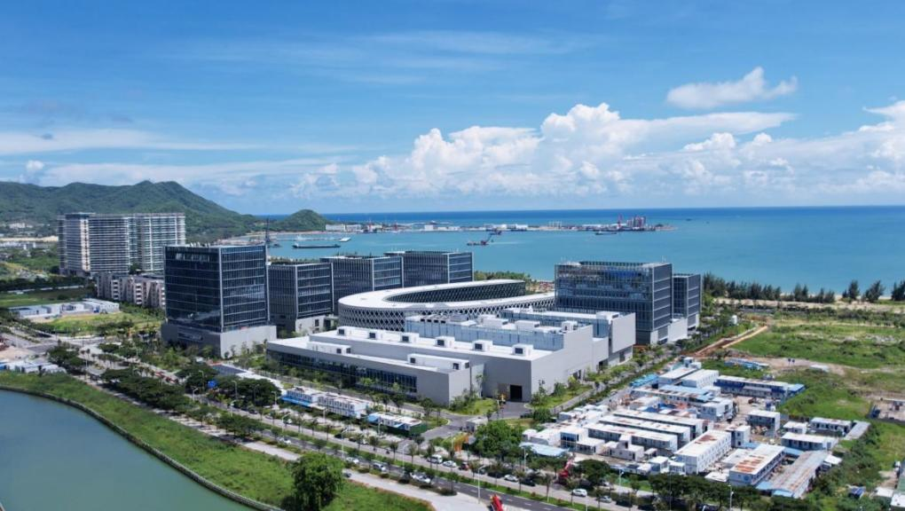**【Yazhou Bay: A Dual Feast of Nature and Innovation】**

Yazhou Bay offers a unique blend of serene natural landscapes, rich marine resources, and vibrant cultural atmosphere. It is home to several 5A-rated tourist attractions, such as the Nanshan Cultural Tourism Zone and the Dongtian Park, providing a wealth of cultural experiences.

From August 28 to 30, the 9th TPO Forum will take place in Sanya, showcasing the unique charm of each bay and inviting guests to explore and experience the diverse offerings.